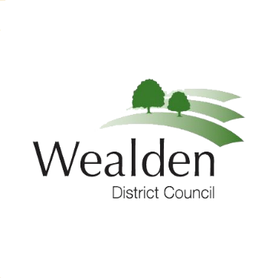

MEDIA RELEASE

019/24 21 February 2024

Council Tax increase of 2.99% approved

A Council Tax increase of £6.23 a year has been approved by Wealden District Council.

The decision to increase the amount by 2.99% was approved by the council’s Cabinet Committee and ratified at a meeting of the Full Council this week.

It means households living in Band D properties will pay an additional 12p a week for its share of the Council Tax for 2024/25, with other bands increased in line with the Council Tax formula.

Wealden council receives 9% of the Council Tax collected and that helps pay for refuse and recycling collections, planning, street cleaning, environmental protection, and free car parking.

The remainder of the Council Tax bill is shared to pay for a wide range of public services provided by East Sussex County Council, Sussex Police, East Sussex Fire and Rescue and local town and parish councils.

Councillor Greg Collins, Alliance for Wealden (Green Party), and lead councillor for Finance and HR, said, “Wealden District Council has decided to increase its share of Council Tax for all bands by 2.99% in 2024/2025. For example, for a typical band D property this means a rise in Wealden’s share of less than £7 a year.
“This rise is significantly below the current rate of inflation, is the same percentage as last year and the maximum allowable rise under central Government rules, as it was last year too. The funding Wealden gets from central government assumes that we will increase council tax by the maximum we are allowed.

“Your council continues to absorb significant cost pressures, just as we are all experiencing continued financial pressures personally. Council Tax simply must rise for the council to continue to provide its services to the community. Total Council Tax bills for Wealden residents will regrettably rise by much more than 2.99%, as people will see when their bills arrive.

“Wealden has no control over the rises made by the other authorities, on whose behalf it simply collects Council Tax, and which make up the lion’s share of residents’ Council Tax bills. Wealden itself only receives 9% of the Council Tax it collects. The services provided to residents from that 9% represent excellent value-for-money.”

For further information please contact:
Laurence Woolven  Head of financial Services  Wealden District Council  Email: laurence.woolven@wealden.gov.uk | Or | Sian Killean  Media and Communications officer  Wealden District Council  Tel: 07970 233231  Email: Sian.killean@wealden.gov.uk

